 | DEPARTMENT OF COMPUTER ENGINEERING
Experiment No.1
Semester | T.E. Semester VI
Subject | ARTIFICIAL INTELLIGENCE (CSL 604)
Subject Professor In-charge | Prof. Avinash Shrivas
Assisting Teachers | Prof. Avinash Shrivas

Student Name | Deep Salunkhe
Roll Number | 21102A0014
Lab Number | 310A

Title:

Water Jug Problem (Menu Driven)

Theory:

The water jug problem is a classic puzzle that involves two jugs with known capacities, and the task is to measure a specific amount of water using these jugs. The jugs can be filled, emptied, and water can be transferred between them.
Objective:
In this program, the objective is to make the 4g jug contain exactly 2g of water.
Jug Capacities:
- 4g Jug (g_4): Represents the jug with a capacity of 4 units.
- 3g Jug (g_3): Represents the jug with a capacity of 3 units.
Program Explanation:
Initial State:
The program starts with both jugs empty (0g in both).

Program Code:

#include<iostream>
using namespace std;

void fill_3g(int &x,int &y){
if(y<3){
y=3;
return;
}else{
cout<<"Already Filled"<<endl;
}
}

void fill_4g(int &x,int &y){
if(x<4){
x=4;
return;
}else{
cout<<"Already Filled"<<endl;
}
}

void empty_3g(int &x,int &y){
if(y>0){
y=0;
return;
}else{
cout<<"Already Empty"<<endl;
}
}

void transfer_all_3g_to_4g(int &x,int &y){
if(x+y<=4 && y>0){
x=x+y;
y=0;
return;
}else{
if(y<=0){
cout<<"3g is empty"<<endl;
}else{
cout<<"Water will over flow"<<endl;
}
}
}

void transfer_all_4g_to_3g(int &x,int &y){
if(x+y<=3 && x>0){
y=x+y;
x=0;
return;
}else{
if(x<=0){
cout<<"4g is empty"<<endl;
}else{
cout<<"Water will over flow"<<endl;
}
}
}

void transfer_some_3g_to_4g_Until_4g_is_Full(int &x,int &y){
if(x+y>4 && y>0 && x<4 ){
y=y-(4-x);
x=4;

return;
}else{
if(y==0){
cout<<"3g is empty"<<endl;
}else if(y==4){
cout<<"4 is already filled"<<endl;

}else{
cout<<"what is not enough to fill 4g"<<endl;
}
}
}

void transfer_some_4g_to_3g_Until_3g_is_Full(int &x,int &y){
if(x+y>3 && x>0 && y<3){
x=x-(3-y);
y=3;

return;
}else{
if(x==0){
cout<<"4g is empty"<<endl;
}else if(y==3){
cout<<"3 is already filled"<<endl;

}else{
cout<<"what is not enough to fill 3g"<<endl;
}
}
}

void empty_4g(int &x,int &y){
if(x>0){
x=0;
return;
}else{
cout<<"Already Empty";
}
}

int main(){

cout << "Let's start the water jug problem" << endl;
cout<<"Task: make 4g jug to have 2g water"<<endl;
int g_4 = 0;
int g_3 = 0;

while (true) {
cout << "\nCurrent States :" << endl;
cout << "4g:" << g_4 << endl;
cout << "3g:" << g_3 << endl;

if(g_4==2){
cout<<"congratulation you are smart!"<<endl;
return 0;
}

cout << "\nMenu:" << endl;
cout << "1. Fill 3g jug\n2. Fill 4g jug\n3. Empty 3g jug\n4. Empty 4g jug\n";
cout << "5. Transfer all from 3g to 4g\n6. Transfer all from 4g to 3g\n";
cout << "7. Transfer some from 3g to 4g until 4g is full\n";
cout << "8. Transfer some from 4g to 3g until 3g is full\n9. Quit\n";

int choice;
cout << "Enter your choice (1-9): ";
cin >> choice;

switch (choice) {
case 1:
fill_3g(g_4, g_3);
break;
case 2:
fill_4g(g_4, g_3);
break;
case 3:
empty_3g(g_4, g_3);
break;
case 4:
empty_4g(g_4, g_3);
break;
case 5:
transfer_all_3g_to_4g(g_4, g_3);
break;
case 6:
transfer_all_4g_to_3g(g_4, g_3);
break;
case 7:
transfer_some_3g_to_4g_Until_4g_is_Full(g_4, g_3);
break;
case 8:
transfer_some_4g_to_3g_Until_3g_is_Full(g_4, g_3);
break;
case 9:
cout << "Exiting the program.\n";
return 0;
default:
cout << "Invalid choice. Please enter a number between 1 and 9.\n";
}

}

return 0;
}

Output:

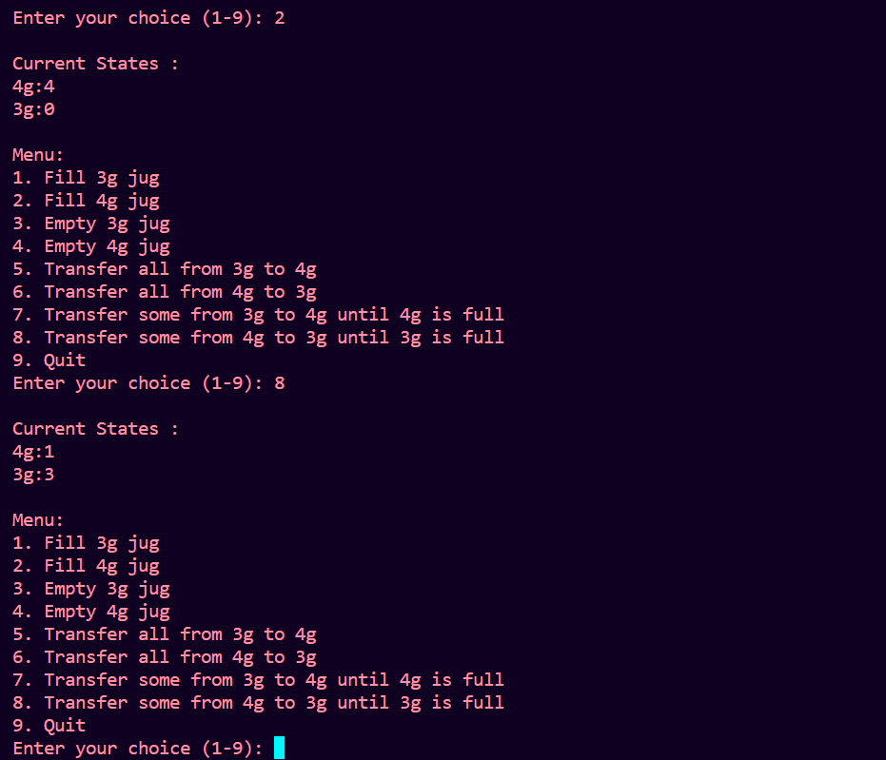

Conclusion:

The water jug problem is a classic example of problem-solving using basic operations such as filling, emptying, and transferring. The provided C++ program effectively simulates the problem and allows the user to interactively perform actions on the jugs to achieve the specified objective.

